Automatic Assessment of Student Answers Consisting of Venn and Euler Diagrams

Abstract—Venn and Euler diagrams are well-defined mathematical diagram types, which are the major representation methods of Set Theory. Venn and Euler diagrams are part of major Mathematics examinations in secondary education such as London Ordinary Level and SAT. Although computer assessment of different diagram types has been addressed, no such research has been done for Venn and Euler diagrams. In this research, we present a system capable of automatically assessing student answers consisting of Venn and Euler diagrams. The student answer is compared against a model answer, and marks are allocated according to a marking rubric.

Index Terms— Diagram Assessment, Venn Diagram, Euler Diagram, Set Theory, Diagram interpretation
- Introduction
Venn and Euler diagrams are a significant part of Mathematics, especially in examinations for secondary education, such as GCE Ordinary Level (UK) and SAT. With the increasing interest in automated assessment of student answers for various subjects including Mathematics, there is a need for an automated system to assess answers containing these types of diagrams. Significant research has been done to understand mathematical diagrams in few domains such as coordinate graphs [1 and 2], as well as charts [3 and 4] (bar charts, pie charts). However, there is no research done to interpret or assess Venn and Euler diagrams.
Venn diagrams can be described as diagrams that represent pictorial relations among sets. Venn diagrams are a specialized instance of a more general notation for representing relationships among a set of classes of concepts, referred to as Euler diagrams [5].
This paper presents a system capable of automatically assessing a student answer containing a Venn or Euler diagram. The system accepts diagrams represented in the scalable vector graphic (SVG) format. Set information is extracted from these SVG images [6] and represented using an abstract syntax. Extracted set information from a student answer is compared against the information extracted from a teacher-provided model answer. Marks are allocated to the student answer using a marking rubric, which should also be provided by the teacher. We have developed a web-based interface for the teacher to specify the marking rubric. Marking rubric generator will provide the necessary information and options to the teacher to generate the rubric according to a model diagram. Marking rubric may contain alternative marking methods for a same question/ sub-question. Maximum collective mark is extracted as the final mark for a student answer.
Evaluation was carried out using answers provided by students who are preparing for the GCE O/L examination held in Sri Lanka. This exam is very much similar to the Landon O/L examination. We manually graded the answer sheets according to the marking rubric. Answer sheets were then converted to SVG and were graded using the system. Marking results produced from the system were validated against the manual marking, which showed an accuracy of 100%.
This paper is arranged into following sections: Section II describes the related work. Details of the implemented system are included in Section III. Section IV provides an evaluation of the system. Finally, Section V concludes the paper with a discussion on possible future extensions.
- Related Work
Mathematical diagram recognition, understanding and evaluation is a relatively new research field, and we are not aware of any related research that dealt with Venn and Euler diagrams. However, there exists research on understanding diagrams such as x-y graphs [1], gene diagrams [1], and charts (both 2D and 3D) [3 and 4].
As for diagram assessment, Tsintsifas et al. [7] developed a framework called DATsys that can be used to understand and evaluate diagrams in formative assessments. The diagram input system can handle various diagram types, such as E-R diagrams, circuit diagrams, and class diagrams. Thomas et al. [8, 9 and 10] developed a computer aided assessment system that can handle graph-based diagrams such as E-R diagrams and flow charts, where information can be represented as data nodes and relations. They also introduced a marking criteria that can be applied to diagrams that are represented using nodes and their relationships. Bligh et al. [11] developed a feedback system that can work with graph-based diagrams by following the work of Tsintsifas et al. [7]. They also discussed a simple evaluation method and developed a grammar for E-R diagrams. Batmaz et al. [12] developed a diagram drawing tool that can be used for semi-automated database diagram assessment. Tselonis et al. [13] discussed a marking method based on marking matrices for graph-based diagrams.
The above assessment techniques cannot be directly adopted to Venn and Euler diagram marking due to the structure differences that exist between Venn/ Euler diagrams and graph equivalent diagrams.
As for machine representation of marking rubrics, Richard et al. [14] presented a way of representing a rubric document in a machine understandable format using XML. Li et al. [15] developed a language for mathematical problem representation called Mathematics Assessment Markup Language (MAML), using XML, MathML and SVG. Researchers claim that they can represent any mathematical problem using MAML mark-up language.
- Methodology
In this section we describe the implementation details of the Venn and Euler diagram parser, Venn and Euler diagram data structure, marking rubric model and the diagram assessment module.
- High-Level Architecture
Figure 1 shows the high-level architecture of the implemented system. The teacher has to provide a marking rubric using the rubric generator and a model diagram to the system (in the form of SVG format) for assessment. System extracts and stores the Venn data structure (described below) from this diagram [4]. Student diagram is processed similarly. In the assessment module, these two Venn data structures are compared and the student answer is graded according to the marking rubric.
In the Assessment module, student diagram is validated for structure similarity such as the number-of-sets. If the structures of two diagrams are matched, assessment is continued. Initially, the set labels in the model diagram and the student diagram are matched using a sentence similarity matching algorithm. After set matching is completed, the diagram is graded according to the marking rubric, which is provided by a teacher.
- Venn Data Structure
Figure 2 shows the abstact sysntax developed for the Venn and Euler data by extending the abstract syntax introduced by Burton et al [16]. We modified the zone notation and added the extra detail segment “No of elements” to handle all the information given in a diagram. In this new abstract syntax, there are five top-level attributes; (1) Label: Labels of the sets, (2) Curves: Related curves drawn to represent sets, (3) Regions: Represent all the zones and minimal regions, (4) No of elements: Elements in the sets, zones or minimal regions, (5) Shaded Zones: zones or regions that are shaded.
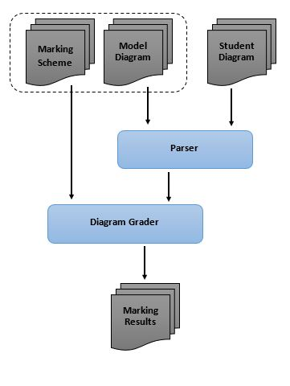
Fig. 1 The High-Level Architecture of the system
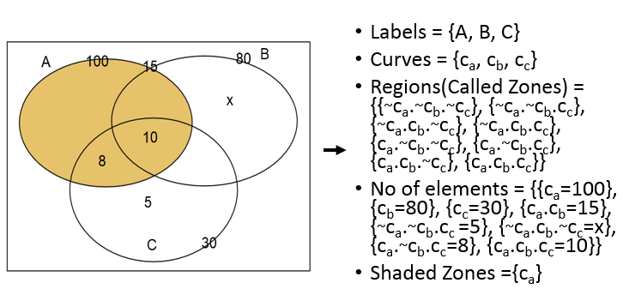
Fig. 2 Venn/ Euler abstract syntax
Set order is ignored in the Venn data structure. Depending on the set order, different Venn or Euler diagrams may produce equivalent solutions.
For a given set, output using the abstract systax can have a limited number (n!) of equivalent formats depending on the arrangement of sets. Figure 3 shows the two Venn diagrams representing the same set information. Variation of Venn or Euler diagram for 2 sets produces 2 equivalent Venn data structures. Figure 4 shows the equivalent formats for two Venn diagram answers shown in Figure 3.
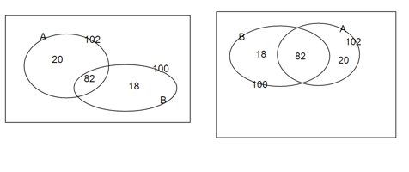
Fig. 3 Two Venn diagram answers providing same information
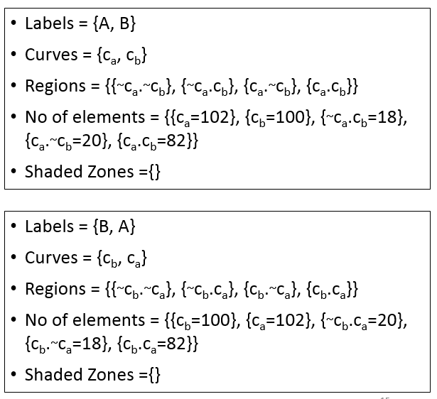
Fig. 4 Equivalent representations using the Venn data structure for answers provided in Fig. 3

- Marking Rubric
Figure 5 shows the marking rubric structure for Venn and Euler diagrams. Each rubric contains type and question attributes. Type attribute specifies the diagram category such as “Venn Diagram” and “Euler Diagram”. Question contains all the specific marking attributes, “id”, “totalMarks” and details about each sub question. Section Each sub_question can have multiple “mark_set” attributes, each specifying one possible solution. Each mark set includes three major attributes; (1) mandatory”: specifying the pre-requirements in order for the given solution to be true, (2) data: condition for the evaluation, (3) feedback: suggested feedback by the teacher. Mark set has “method” attribute specifying the way to give marks such as “all of the conditions have to be true”, “at least 3 conditions have to be true”, and “any condition has to be true”. “data” part contains the diagram queries (given in Table I) that have to be checked. These queries represent the requiremnts for assessment. It can check for sets, zones, labels and colors regardless of the drawing orientation.
TABLE I. RUBRIC DIAGRAM QUERIES FOR THE ASSESSMENT
Description | Syntax | Example
Existence of Set with a given identifier | set id=[identifier] | set id=‘A’
Existence of Zone with a given identifier | zone id=[identifier] | zone id=‘A.B.C’
Existence of Zone with a given identifier and label | zone id=[identifier] label=[label] | zone id=‘A.B.C’ label=‘10’
Existence of Zone with a given identifier and color | zone id=[identifier] color=[color] | zone id=‘A’ color=‘orange’
Existence of Zone with a given identifier, label and color | zone id=[identifier] label=[label] color=[color] | zone id=‘A’ label=‘100’ color=‘orange’

- Rubric Generation
When the model diagram is submitted by the teacher, teacher will be provided with web interface for the rubric generation. Model diagram is sent to the web server for parsing. Then using the parsed data, data needed to populate the rubric is send to the rubric generator. Using that data, rubric generating options are provided to the teacher.
Figure 6 shows the rubric generation interface for the diagram showed in figure 3. Teacher can add subquestions, multiple marksets for each subquestion. Mark set attribute options are provided. Teacher can select the marking method for a marking set and set the marks for each mark set. For each mark set, teacher can select diagram quries using the options given according to the venn diagram.
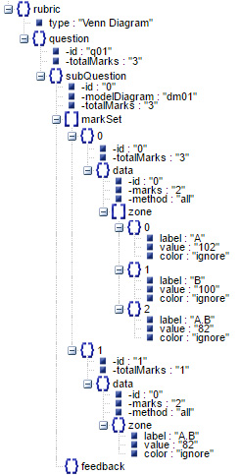

Fig. 5 Sample marking rubric for a question

- Text Label Matching
Labels in the diagrams are written in the Sinhala language (the official language in Sri Lanka) and it can be a single word or a short phrase. Algorithm 1 shows the pseudo code of the label validation module. First, it checks if the labels in the student’s answer directly match with one of the labels found in the model answer labels. If it matches, the system evaluates student label as correct. If not, using the question and the labels provided in the model, this module forms a word joint vector (Bag of Words).
Then Similarity matrix is formed using model answer labels and the student answer labels. Next, the system calculates cosine similarity between pairs of column vectors in the matrix. Finally, it selects the maximum similarity value and the relevant model answer and it calculates the Levenshtein (edit) distance (LD-min). Then it calculates the maximum edit distance (LD-max) between the selected label and the label in the student’s answer. Finally, it checks whether the minimum edit distance is less than or equal to the maximum edit distance between student unit, and the selected unit multiplied by a tolerance value (T_{val}). Using the training data collection, the tolerance value is tuned to be 0.51.
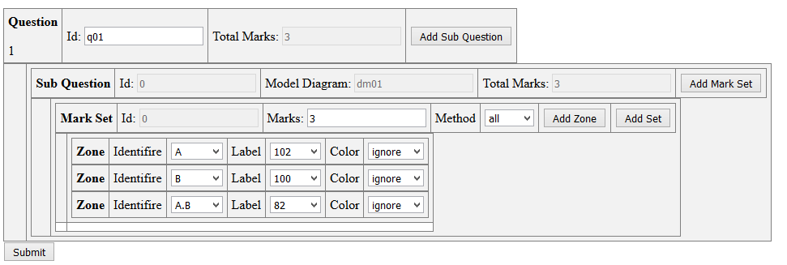
Fig. 6 Rubric Generator web interface for the Venn diagram in Fig.3
Based on the similarity, matching set label pairs are identified.
- Assessment Module
In the assessment, the diagram is initially checked for mandatory requirements such as the number of sets. If the number of sets match, similar sets are identified by matching the set names. If a diagram has N sets, at least N-1 set names have to be matched correctly for the assessment.
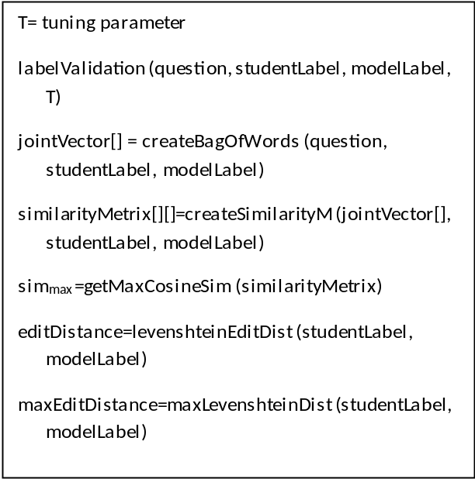
Algorithm 1. Label validation logic.
After matching relevant sets, according to the marking rubric, for each sub-question, all mark-sets are evaluated until at least one mark set gains maximum marks allocated for that sub-question. Then the mark set with maximum marks for that sub-question is collected as the final marks for that sub-question.
Similarly, each sub-question in the marking rubric is graded and total mark is calculated from collective marks for sub-questions.
- Evaluation
Figure 7 shows a model answer for a Venn diagram question that has 3 sets presenting sport details of a class of students. A student answer is given in Figure 8, which represents the same set details. Set orientation is different in two diagrams, as well as with respect to label positions. Set labels have differences and have spelling mistakes (the third set is labelled as “Caram” instead of “Carom”). In the set label matching phase, these sets are matched. {“Badminton”, “Play Batminton”}, {“Cricket”, “Play Cricket”} and {“Carom”, “Play Caram”} are identified as matching pairs. Then the student diagram is marked according to the marking rubric by comparing the data tuples in the Venn data structure, and the results are presented. Since in the set theory set order details are not significant, by omitting the sets order in the Venn data, the equivalency of two diagrams can be measured.
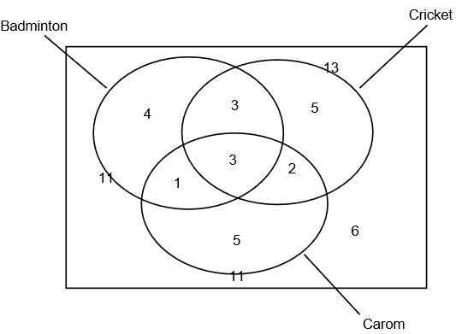
Fig. 7 Model answer for a question
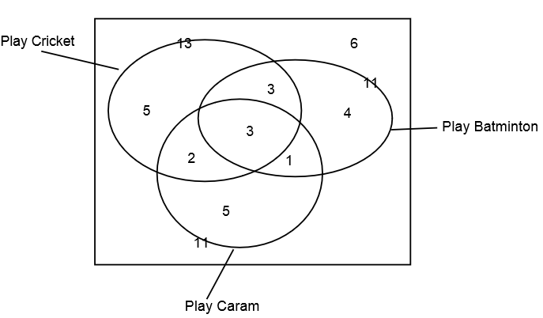
Fig. 8 Student answer for a question

Assessment module was tuned using more than 30 Venn diagrams gathered from university undergraduates, which are drawn directly using an SVG editor. For testing, we collected hand-written answer scripts, which collectively contained 3 Venn and 4 Euler diagrams from university undergraduates and grade 10 school students. In total, we had 85 Venn and Euler diagrams. Those diagrams were hand-drawn. Therefore they were converted to Vector format using an SVG editor. The model answer for each question was drawn similar to the marking scheme and the marking rubric was generated according to the marking scheme provided originally in the exams. The assessment answers were graded and validated against the manual marking. Error identification results were validated by shown to two domain experts.
Table II shows the evaluation results for the assessment. Diagrams 5 and 6 contain 2 sets and remaining diagrams contains 3 sets. Diagram 5 and 6 were collected from school student answer scripts and remaining from university undergraduates. The assessment module successfully graded all of those diagrams, having a collective accuracy of 100%. Table IV shows the evaluation results for error identification, also shows the accuracy of 100%.

TABLE II. EVALUATION RESULTS FOR DIAGRAM ASSESSMENT
Diagram No. | Diagram Type | Total Diagrams | Correctly Marked against manual assessment | Accuracy
1 | Venn | 7 | 7 | 100%
2 | Euler | 10 | 10 | 100%
3 | Euler | 8 | 8 | 100%
4 | Venn | 8 | 8 | 100%
5 | Venn | 19 | 19 | 100%
6 | Venn | 33 | 33 | 100%

- Conclusions
In this research, we introduced a marking rubric modeling method and an assessment method for Venn and Euler diagrams. The teacher’s involvement is needed only at the question set up time. The teacher is provided a simple web-based interface to specify the marking rubric. We believe that the solution we have introduced can be incorporated into develop educational learning systems and systems that require Venn and Euler diagram assessment.
The assessment module is currently optimized for the diagrams given in O/L examination in Sri Lanka. Assessment module can be extended for other languages and different examinations based on the marking requirement criteria.
Acknowledgment
Provided upon paper acceptance.

References
- R. P. Futrelle and N. Nikolakis, “Efficient analysis of complex diagrams using constraint-based parsing. In Document Analysis and Recognition,” in Proceedings of the Third International Conference on IEEE, 1995, Vol. 2, pp. 782-790.
- R. P. Futrelle, I. Kakadiaris, J. Alexander, C. M. Carriero, N. Nikolakis, and J. M. Futrelle, “Understanding diagrams in technical documents,” in IEEE Computer, 1992, Vol. 25(7), pp. 75-78.
- W. Huang, C. Tan, “A System for Understanding Imaged Infographics and Its Applications,” in Proceedings of the 2007 ACM symposium on Document engineering - DocEng '07, 2007, pp. 9-18.
- W. Huang, C. Tan, and W. K. Leow, “Associating text and graphics for scientific chart understanding,” in Document Analysis and Recognition,” in Proceedings of the Eighth International Conference on IEEE, 2005, pp. 580-584.
- P. A. Rodgers, “A survey of Euler diagrams,” Journal of Visual Languages & Computing, vol 25(3), pp. 134-155, 2014.
- Anonyumous, 2016
- A. Tsintsifas, "A framework for the computer based assessment of diagram based coursework," in Computer Science and Information Technology, 2002.
- P.Thomas, K. Waugh, and N. Smith, "Experiments in the automatic marking of ER-diagrams," ACM SIGCSE Bulletin, Vol 37(3), pp. 158-162, 2005.
- P. Thomas, K. Waugh, and N. Smith, "Generalised diagramming tools with automatic marking," Innovation in Teaching and Learning in Information and Computer Sciences Vol 10(1), pp. 22-34, 2011.
- P. Thomas, K. Waugh, and N. Smith, "Using patterns in the automatic marking of ER-diagrams," ACM SIGCSE Bulletin. Vol. 38(3), pp. 83-87, 2006.
- B. Bligh and C. A. Higgins, "Formative computer based assessment in diagram based domains." ACM SIGCSE Bulletin, Vol 38(3), pp. 98-102, 2006
- F. Batmaz and C. J. Hinde, "A diagram drawing tool for semi–automatic assessment of conceptual database diagrams," 2006, pp. 71-84.
- C.Tselonis, J. Sargeant, and M. M. Wood, "Diagram matching for human-computer collaborative assessment," Proceedings of the 9th CAA Conference, 2005.
- R. F. Boehme, P. G. Fairweather, U. Farooq, D. Lam and K. Singley, "Method, apparatus and computer program code for automation of assessment using rubrics," U.S. Patent Application No. 10/722,926, 2008
- G. Li, W. Su, Y. Zhao, and L. Li, "Design and implementation of MAML," in Proceedings of ATCM, 2006.
- J. Burton, G. Stapleton, J. Howse, and P. Chapman, “Visualizing Concepts with Euler Diagrams,” in Proceedings of International Conference on Theory and Application of Diagrams, 2014, pp. 54-56.

Shaded zone is used to indicate a subset. This is the common representation method in Set Theory.
System supports both English and Sinhala languages
Even though research was validated using the Sinhala Language, we have used an example in English so that a wider audience can understand.

